Study Timeline
IRB Approved at the Protocol Level
Mar 13, 2025
20250377
#42667888.0
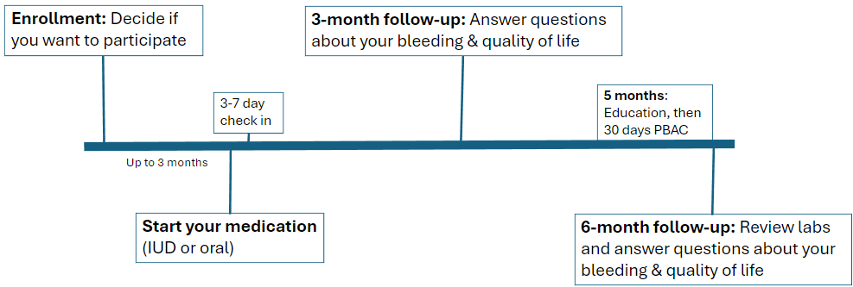
Before you are asked to participate in this study your doctor will determine if you are eligible, and you and your doctor will have decided that either a progesterone intrauterine device (IUD) or oral progesterone is the right treatment for you to help with your heavy period bleeding.
If you choose to participate in this study, the study team will collect information from you 5 different times either at your doctor’s office or through online surveys. Communications will come to you via text messages or email from a system called REDCap – this keeps your information secure.

Enrollment
You will be asked questions about your medical history related to bleeding, your period bleeding, and medications you are taking. Laboratory testing that your doctor has obtained to see if you have a bleeding disorder and to see if your body is low in iron will be reviewed.
You will complete the following questionnaires – note: if your medication starts more than 1 month after this visit, and you will receive a REDCap communication when it is time to complete these forms.
- PROMIS and adolescent menstrual bleeding quality of life questionnaires
- A series of questions related to your current period bleeding

NETA Start or IUD Placement
You will either have your IUD placed or you will receive a prescription to be able to start on your oral medication (NETA).

You will complete the following questionnaires:
- A series of questions related to your current period bleeding
- If you are taking the oral medication, we will send you a REDCap form to confirm the date you started your oral medication

3-month follow-up

You will complete the following questionnaires:
- Questions about any medical changes and any medicines that you have taken since your last study visit.
- PROMIS and adolescent menstrual bleeding quality of life questionnaires
- A series of questions related to your current period bleeding
- Questions to determine if you are satisfied with your current medication and if you have continued the medication you started (in the case of the IUD the questions will be related to whether or not your IUD is still in place).

5-month follow-up
You will have pictorial bleeding assessment chart (PBAC) training. The PBAC is a picture-based scoring system that helps us know how much blood you are losing with each period. Following your training, for 30 days you will be sent a REDCap survey asking about your menstrual bleeding using the PBAC

6-month follow-up
You and your doctor will again review your laboratory testing that was obtained to see if you have a bleeding disorder and to see if your body is low in iron; you will only have this repeat laboratory testing done if your doctor thinks it is important for your medical care outside of study participation. You will complete the following questionnaires:
- Questions about any medical changes and any medicines that you have taken since your last study visit.
- PROMIS and adolescent menstrual bleeding quality of life questionnaires
- A series of questions related to your current period bleeding
- Questions to determine if you are satisfied with your current medication and if you have continued the medication you started (in the case of the IUD the questions will be related to whether or not your IUD is still in place).
Your total time in the study will be 6-12 months. The variability is based on when you start your drug and exactly when your follow-up visits are scheduled. After you initiate your drug – oral NETA or IUD – the study takes about 6 months.

